MCG2101 – Intro Design of MCG Systems

Deliverable 3
Group 13

Names:
Haneen Barghouti
Lara Al Nakeeb
Emma Cochran
Linh Nguyen
Toshio Woo

Table of Contents
Decisional Analysis 3
Preparation to Design 4
Gantt Chart 12
References 14

List of Figures:

Figure 1 Decisional Analysis Table 3
Figure 2 Gantt Chart [1] 12
Figure 3 Gantt Chart [2] 13

List of Tables:
Table 1. Leadership Distribution 4
Table 2. Toshio Woo - Locomotion System Lead: Klann Linkage 5
Table 3. Emma Cochran - Sampling Mechanism Lead: Gear Actuated Tube 6
Table 4. Linh Nguyen - Buoyancy System Lead: Buoyancy Chamber 7
Table 5. Lara Al Nakeeb - Wear Resistance Lead: Wear Resistant Material 8
Table 6. Haneen Barghouti - Stability Lead: Large Friction Contact Surface 10
Table 7. Team Checkpoints 11

Decisional Analysis
The following decisional analysis table determines the effectiveness of each solution at completing the criteria and restrictions. The complete solution with the highest final score is the one that best satisfies the mandate and will be chosen for realization.
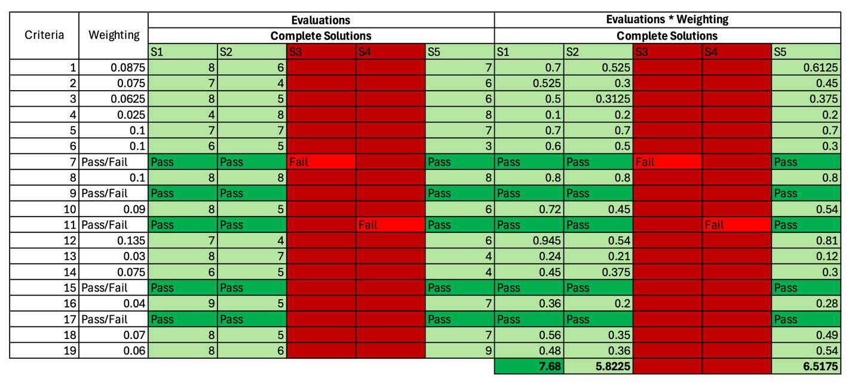
Figure 1 Decisional Analysis Table

Upon completing the decisional analysis table, solution 1 has been determined as the solution which best fulfills the criteria and restrictions.

Preparation to Design
Distribution of Leadership:
Table 1. Leadership Distribution
Subsystem | Basic Solution | Team Member | Role
Locomotion System | 1.3 Klann Linkage | Toshio Woo | Lead leg design and transmission
Sampling Mechanism | 2.3 Gear Actuated Tube | Emma Cochran | Lead sampling mechanism deployment design
Buoyancy System | 3.1 Buoyancy Chamber | Linh Nguyen | Lead modulation system of buoyancy chamber
Wear Resistance & Structure | 4.2 Wear Resistant Material | Lara Al Nakeeb | Lead material selection & reinforcement design
Stability System | 5.3 Large Friction Contact Surface | Haneen Barghouti | Lead stability & contact optimization strategy

The team member designated to each basic solution will be responsible for coordinating and overseeing the tasks in their respective realization strategies.

Group Members Distribution Schedules:
Table 2. Toshio Woo - Locomotion System Lead: Klann Linkage
Task | Target Date
Define movement requirements (step height, stride length, speed - 0.2 m/s target) | Feb 24
Research & outline preliminary Klann linkage | Feb 26
Establish leg size and movement space/clearance (cannot interfere with other systems) | Feb 27
Define linkage crank input and rotation speed (crab speed & gear ratios) | Feb 28
Estimate torque needed for propulsion using friction assumptions | Mar 3
Share required shaft diameter + bearing loads for crab structure | Mar 4
Size the link lengths proportionally for desired leg movement; decide on joint angles | Mar 6
Determine left and right-side leg phasing (1&3, 2&4 leg coordination) | Mar 8
Confirm that step height and stride work on ocean floor terrain | Mar 9
Use frame (from wear & structure lead) to adjust leg mounting | Mar 10
Ensure compatibility with sampling deployment (sampling deployment should not interfere with leg movement) | Mar 13
Ensure compatibility of legs with footpad mounting (from stability lead) | Mar 15
Model full leg assembly in SolidWorks | Mar 18
Check final possible interferences with other subsystems | Mar 24
Finalize all dimensions | Mar 27
Finalize and share locomotion assembly | Mar 27

Table 3. Emma Cochran - Sampling Mechanism Lead: Gear Actuated Tube
Task | Target Date
Confirm possible sample sizes | Feb 24
Define tube diameter and required extension length | Feb 26
Share tube deployment path and clearance requirement (to design interfering with legs) | Feb 28
Select Archimedes screw pitch and length (based on estimated sample sizes & leg/crab size) | Mar 2
Estimate required screw torque for sample collection | Mar 4
Research and determine required gear ratio and internal gear layout | Mar 6
Share required mounting area and connection to body with structure lead | Mar 8
Ensure that tube deployment does not interfere with legs after mounting | Mar 10
Design and position sample sealing mechanism | Mar 12
Ensure no interference with buoyancy chamber placement with buoyancy system lead | Mar 14
Estimate possible seafloor disturbance; ensure compliance with criteria | Mar 16
Begin modeling full deployment mechanism in SolidWorks | Mar 18
Integrate into SolidWorks model | Mar 24
Final interference test with locomotion | Mar 25
Finalize dimensioning | Mar 27
Share finalized sampling assembly | Mar 27

Table 4. Linh Nguyen - Buoyancy System Lead: Buoyancy Chamber
Task | Target Date
Get weight estimate from structure and wear lead | Feb 26
Research and estimate volume displacement required for neutral buoyancy | Feb 28
Determine needed chamber volume and compressed air volume | Mar 2
Shares need chamber space (including canister, valves, balloon) | Mar 3
Ensure chamber placement will not interfere with sampling tube | Mar 6
Estimate center of mass effect on stability with wear/structure lead & stability lead | Mar 8
Decide on buoyancy chamber size based on updated mass from wear/structure lead | Mar 10
Confirm water inlet/outlet does not conflict with legs | Mar 12
Define buoyancy range possible by system | Mar 14
Verify buoyancy is within needed depth (6m) | Mar 15
Integrate chamber into SolidWorks design | Mar 23
Ensure proper integration with other systems | Mar 23
Finalize dimensioning | Mar 25
Share finalized buoyancy subsystem | Mar 27

Table 5. Lara Al Nakeeb - Wear Resistance Lead: Wear Resistant Material
Task | Target Date
Confirm Duplex Stainless Steel selection | Feb 23
Establish overall body size (size constraint 60–90 mm) | Feb 24
Share frame SolidWorks skeleton | Feb 28
Decide on a common system for how parts attach | Mar 1
Make a rough estimate of the mass of the robot | Mar 3
Share mass + center of mass estimate with Member buoyancy and locomotion leads | Mar 4
Design internal supports for the structure, wall thickness and stress zone | Mar 9
Design frame features to support shaft (from locomotion lead) | Mar 12
Design sampling mounting bracket (from sampling mechanism lead) | Mar 14
Design buoyancy chamber supports (from buoyancy chamber lead) | Mar 17
Check that system components don’t interfere with each other | Mar 20
Recalculate mass and center of mass and verify compliance with weight constraint (<3 kg) | Mar 22
Determine assembly sequence | Mar 24
Design of final frame | Mar 27

Table 6. Haneen Barghouti - Stability Lead: Large Friction Contact Surface
Task | Target Date
Determine friction coefficient for seabed by estimating grip needed. | Feb 25
Estimate each leg’s normal force (with locomotion lead) | Feb 27
Research and select pad material (corrosion resistant) | Mar 1
Share the footpad size/shape and mounting interface to the leg (with locomotion lead) | Mar 3
Design footpad geometry for grip and minimal disturbance of sand | Mar 5
Confirm compatibility with leg (locomotion lead) | Mar 7
Adjust pads based on torque force based on the legs (with locomotion lead) | Mar 12
Integrate design of pads into locomotion CAD | Mar 15
Simulate stability with uneven terrain | Mar 17
Adjust integrated design for terrain variation | Mar 18
Ensure that footpad format does not prevent clearance from the ground | Mar 19
Check for interference of parts with each other | Mar 22
Design of final pad | Mar 25
Finalize stability subsystem | Mar 27

Table 7. Team Checkpoints
Team checks | Date | Purpose
Layout design freeze | Mar 1 | Overall subsystem placement is agreed on
Mounting design freeze | Mar 12 | Mounting mechanisms for compatibility
Mass & Buoyancy confirmed | Mar 18 | To ensure design is based on a finalized mass and center of mass
Review integrated system | Mar 24 | Ensure complete assembly works and ensure there is no interference between subsystems

Gantt Chart
The following Gantt chart indicates the order and timeline in which each task will be completed for each subsystem for each person.
Figure 2 Gantt Chart [1]
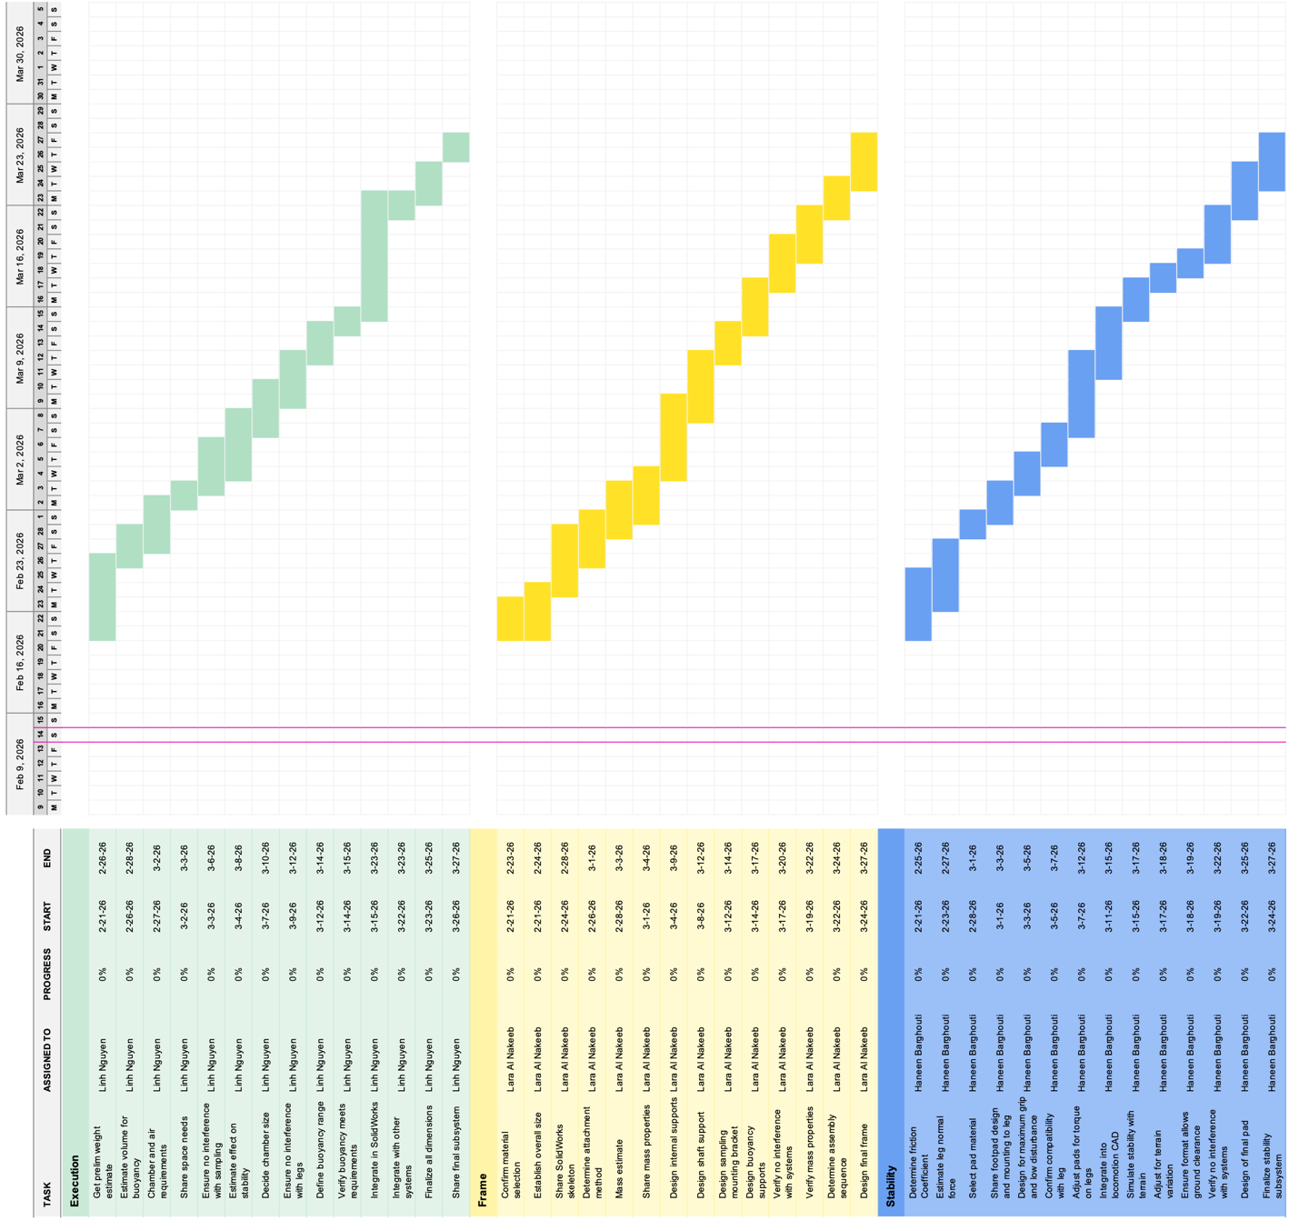
Figure 3 Gantt Chart [2]

References

[1] “Simple Gantt Chart,” Vertex42.com, 2019. https://www.vertex42.com/ExcelTemplates/simple-gantt-chart.html?utm_source=ms&utm_medium=file&utm_campaign=office&utm_content=url#google_vignette

